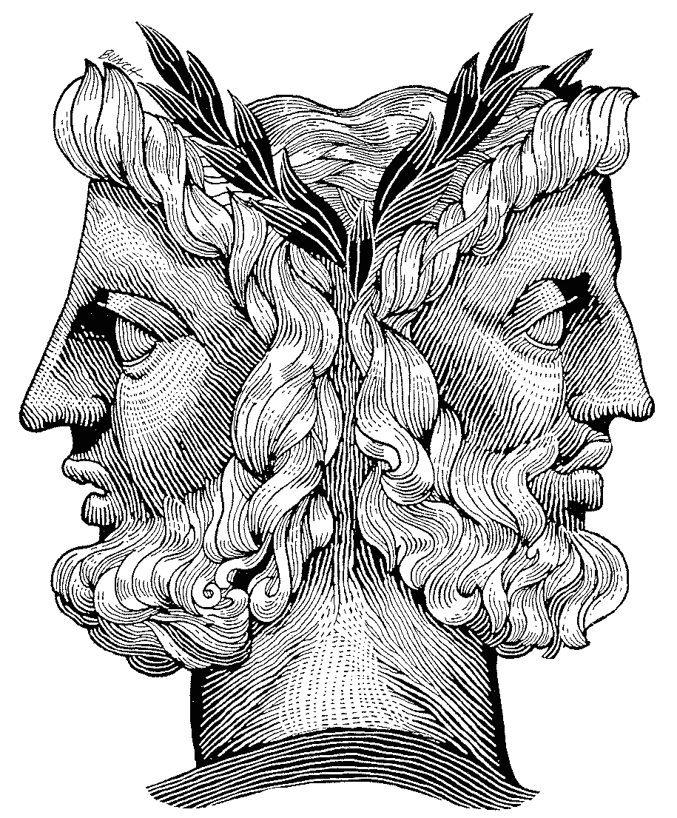
The Janus paradox
In ancient Roman religion and myth, Janus is the god of beginnings and transitions, and thereby of gates, doors, doorways, passages and endings. He is usually depicted as having two faces, since he looks to the future and to the past. It is conventionally thought that the month of January is named after Janus (Wikipedia)
Leaders have to become gifted at facing in (at least) two directions WITHOUT appearing two-faced.
The challenge is often to represent positions, opinions and predicaments to other people’s satisfaction while adding your interpretation as a leader. You may have to represent..
Who? Or What? | To?
Your boss | Your team
Your team | Your boss
Your service | Your governance
Your governance | Your service
Your audiences | Your colleagues
Your corporate vision | Anyone showing an interest
Etc | etc

In each case, how you do this will influence others’ views of your integrity as a leader. Your word and your viewpoint will be scrutinised whether you want it to be or not. You will have to choose carefully what you say and how.
Dos | Don’ts
Be prepared to be unpopular at times | Go native; and get a reputation for obstinate loyalties
Listen.. and show you’re listening | Be impatient about others’ views
Demonstrate understanding & empathy | Appear to make arbitrary decisions
Agree and disagree openly | Be afraid of challenge or discomfort
Be persuadable | Be too easily swayed
Ask for considering-the-issue time | Dismiss plans B, C, D…
Explain multiple positions where necessary | Miss any opportunity of debating options & choices
Turn majority decisions into consensus wherever possible | Wield hierarchy as a ‘put-down’ or use borrowed power
Work at ‘closing the deal’ | Forget to give follow-up and ‘new development’ info

