**POST TITLE:** Volunteer Co-ordinator

__________________________________________________________________________________

**LOCATION:** Trimontium Museum Melrose

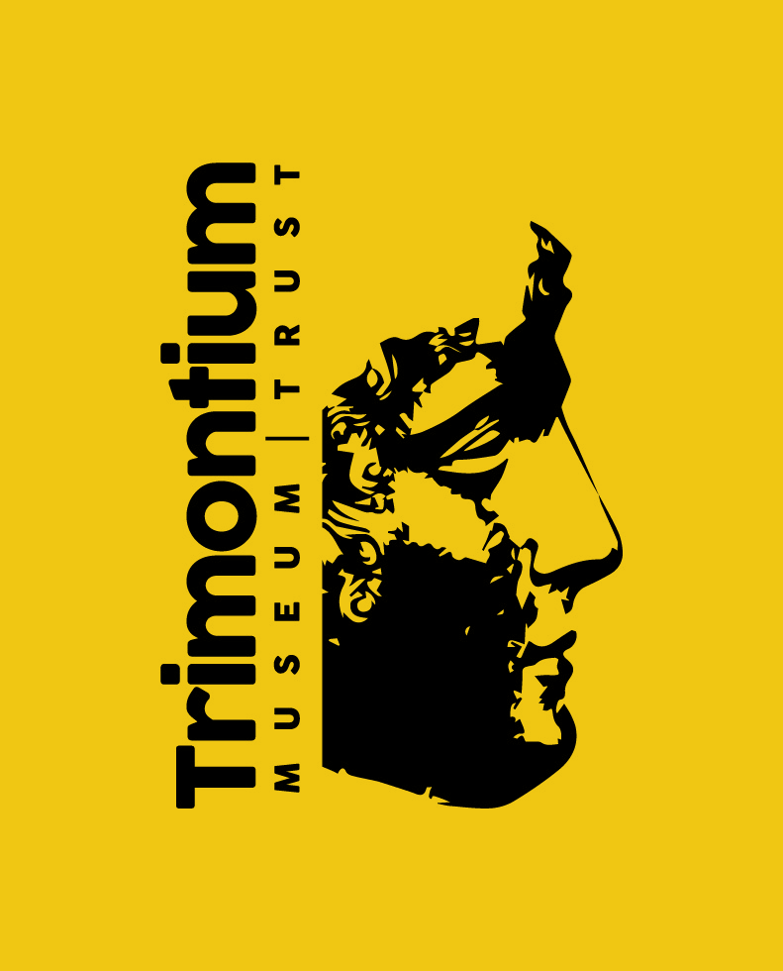

**RESPONSIBLE TO:** Heritage Resources Development Officer

**RESPONSIBLE FOR:** Museum volunteers

**SALARY:** £10,870p.a. pro rata

**HOURS/WORK PATTERN:** 17.5 hours per week

**POST STATUS:** Temporary until end December 2021

**CONTRACT STATUS:** Fixed Term temporary contract

**DISCLOSURE STATUS / PVG REGISTRATION** Enhanced

**Background to Project**

This £1.2m project proposes the upgrade and expansion of the Trimontium Museum in Melrose. The museum tells the story of the Trimontium Fort, near Newstead, a mile from Melrose and plans for new interpretation will place this in the wider context of Iron Age Scotland and the wider significance of the fort in the South of Scotland. The learning programme for the museum will build on the excellent track record of the museum, extend to reach new audiences, create opportunities for participation in a broad range of activities and inspire a new generation of museum volunteers. The museum is entirely volunteer run and will continue to be volunteer run at the end of the project. Project officers will be employed to deliver the Activity Plan, working alongside project management consultants.

**Project Delivery Structure**



**Purpose**

You will be responsible for managing the museum’s volunteer workforce to support the first two years delivery of a 3-year Activity Plan for the Trimontium Museum which has been designed to bring out the full learning potential of the museum and its collections. You will work closely with the Heritage Resources Development Officer to ensure joint planning and communications, and to match volunteers to opportunities generated by the Activity Plan. You will also liaise with Volunteer Centre Borders, Borders College, schools and other 3rd Sector organisations to identify, recruit, train and retain volunteers. You will be a strong leader and motivator. By the end of the first two years the volunteer workforce will have expanded and have the capacity to take responsibility for a wide range of tasks to sustain the intended outcomes of the project.

**PRINCIPAL DUTIES AND RESPONSIBILITIES**

You will be responsible for day-to-day volunteer management, updating policy and practice using volunteer plan produced during the project’s development phase.

1. Manage the existing volunteer team to ensure the day to day running of the museum front-of-house and behind scenes activities.

2. Assist with the development and supervision of additional volunteers by working with local volunteering organisations and schools to recruit new volunteers (as described in the Activity Plan).

3. Organise volunteer work plans to ensure effective programme delivery.

4. Collect and collate records of volunteer hours relating to project activities.

5. Create volunteer training programmes to develop skills required to deliver the project.

6. Manage the budgets for volunteer training and expenses.

7. Work with the Heritage Resources Development Officer to identify and secure external funding for volunteer training and development programmes.

8. Update volunteering policies and procedures for the museum, in line with current best practice in volunteer management.

9. Ensure volunteers deliver high standards of customer care and visitor experience

10. Supervise monthly basic front-of-house finance activities including retail, collating receipts, overseeing gift aid report, collating records of volunteer hours

11. Liaise with the Heritage Resources Development Officer to link volunteer development to opportunities generated by the Activity Plan.

12. Contribute to project evaluation and reporting: liaise with the HRDO to ensure effective monitoring and evaluation of performance and reporting to an agreed schedule for service funders and stakeholders.

13. Ensure all necessary facility checks are carried out in a timely fashion and ensure all basic maintenance tasks are adhered to

14. Assist in maintaining the security of the Museum and museum visitors

15. Health & Safety – Ensure full health & safety procedures are adhered to during opening hours and assist in managing overall adherence to health & safety procedures

16. Undertake any other duties and responsibilities as required by the Trust, commensurate with the grade of the post.

17. The post holder will be expected to work occasional evenings and weekends.

**APPLICATIONS**

Completed application forms should be returned by email by **12 noon, Monday 4th November** to:

rachel.hunter2@hotmail.co.uk

**INTERVIEWS**

Selected candidates will be invited to interview in Melrose on **21st November**

**PERSON SPECIFICATION**

**POST TITLE:** Volunteer Co-ordinator

_________________________________________________________________________________

**EDUCATION / QUALIFICATIONS:**

**Essential**

Five Nat 5 grade A-C (or equivalent) including English and Maths

**Desirable**

Educated to degree level in a subject related to the Museum

**EXPERIENCE**

**Essential**

* Previous experience of supervising/managing a team of volunteers in a busy environment
* Cash handling experience

**Desirable**

* Specific experience of managing volunteers in a heritage context
* Experience of developing effective and sustainable partnerships with organisations within the voluntary and public sectors
* Knowledge of and interest in archaeology Roman/Iron Age history

**SKILLS AND KNOWLEDGE**

**Essential**

* Excellent people management skills including the ability to recruit. Manage, lead and motivate a team of volunteers
* Excellent interpersonal skills including the ability to communication clearly, lead and show tact and diplomacy when necessary
* Ability to manage priorities to deliver agreed outcomes by a defined date
* Ability to work independently and with minimal direction
* Working knowledge of Microsoft packages

Desirable

* Understanding of social media, its strengths and weaknesses
* Flexible and innovative approach

**PERSONAL ATTRIBUTES**

**Essential**

* Approachable, friendly, outgoing and motivated by working towards targets
* Good Communication skills, both oral and written
* Ability to effectively work alone and as part of a team
* Ability to work under pressure, prioritise and meet deadlines
* Commitment to continuous professional development
* Flexible and adaptable
* Self-motivated and able to show initiative

Full driving licence is required.

**PRE-EMPLOYMENT CHECKS**

**Essential**

* PVG certificate clearance
* Confirmation of Right to Work in the UK
* Pre-Employment Health Check
* References
* Confirmation of qualifications required to meet the essential criteria on the person specification

**Right to Work in the UK**

Under the Immigration, Asylum and Nationality Act 2006 – require original documentation confirming legal entitlement to live and work in the UK.

A Passport/National Identity Card showing you are a British Citizen / an EEA or Swiss National or

a **full** British Birth/Adoption Certificate along with an official document containing your name and permanent National Insurance number

**or** a passport or travel document endorsed to show that you are allowed to stay in the UK indefinitely or for a limited period of time and are allowed to work is required.

Please note that a Short Birth Certificate and a Driving Licence are not sufficient to show your entitlement to work in the UK.