**POST TITLE:** Historic Resources Development Officer

__________________________________________________________________________________

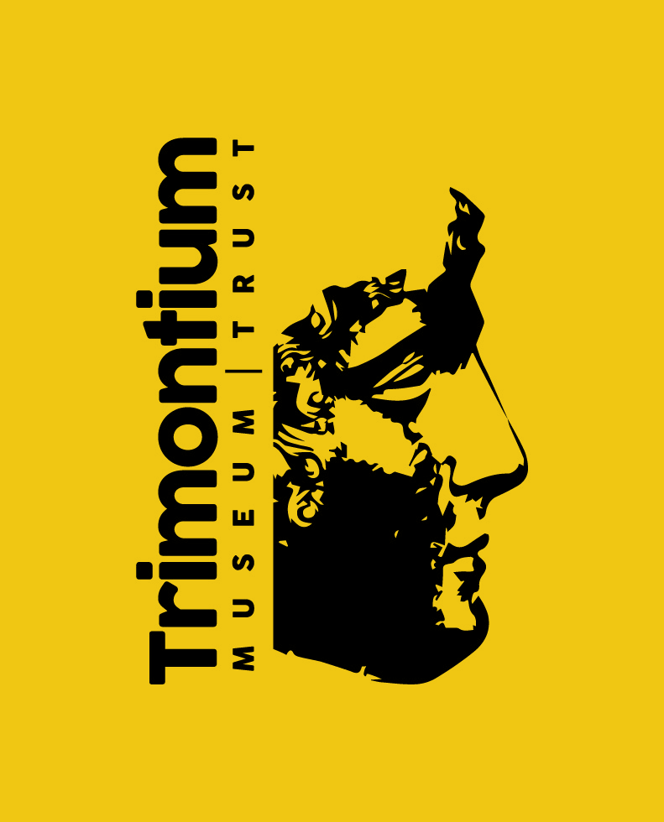

**LOCATION:** Melrose and Selkirk

**RESPONSIBLE TO:** Trimontium Museum Renovation Working Group

**RESPONSIBLE FOR:** Volunteer Co-ordinator

**SALARY:** £24,250 p.a.

**HOURS/WORK PATTERN:** 36 hours per week. The post holder will receive 25 days paid annual leave in addition to Bank Holidays. The normal working week is a five-day week in the period Monday to Friday and the normal working day will be 9am to 5pm, however some flexibility will be expected as the need to do occasional evening and weekend duties will be required.

**POST STATUS:** Temporary until August 2022

**CONTRACT STATUS:** Fixed Term temporary contract

**DISCLOSURE STATUS / PVG REGISTRATION** Enhanced

**Background to Project**

This £1.2m project proposes the upgrade and expansion of the Trimontium Museum in Melrose. The museum tells the story of the Trimontium Fort, near Newstead, a mile from Melrose and plans for new interpretation will place this in the wider context of Iron Age Scotland and the wider significance of the fort in the South of Scotland. The learning programme for the museum will build on the excellent track record of the museum, extend to reach new audiences, create opportunities for participation in a broad range of activities and inspire a new generation of museum volunteers.

**Project Delivery Structure**



**Purpose**

You will be responsible for implementing a 3-year Activity Plan for the Trimontium Museum which has been designed to bring out the full learning potential of the museum and its collections, and consolidate existing good working relationship with Live Borders Museums and Galleries, National Museums Scotland, Historic Environment Scotland and Scottish Borders Council Archaeology. The emphasis of our activities is to encourage public participation in archaeology. We are planning to pursue this in tandem with Dumfries & Galloway Council and you will be expected to work in liaison with a counterpart post located in Dumfries. You will be line managed by the Chair of the Trust and receive mentoring and advice from our consultancy in the first year.

**PRINCIPAL DUTIES AND RESPONSIBILITIES**

1. Implement and continue to develop a 3-year Activity Plan for Trimontium Museum, including creation of learning resources, delivery of a community archaeology programme, management of an intern programme, planning and delivering learning events for our target audiences, commissioning workshops, talks and demonstrations to support this programme, including:

* Produce briefs and contract freelance workers to support delivery of Activity Plan where required
* Carry out detailed planning of activities outlined in the Activity Plan, liaising with Dumfries & Galloway Council and other external partners where necessary
* Liaise with volunteers and Museum Mentor regarding management and care of the museum collection

2. Line manage the Volunteer Co-ordinator

3. Assist during the construction phase to raise awareness and engagement of the project, including:

* Develop an outreach programme to maintain the profile of the museum during the closed phase
* Work with our Youth Panel and Activity and Interpretation Working Group to test plans for interpretation, including a digital design project to interpret the fort site
* Plan ahead for launch events to mark the reopening of the museum
* Issue project progress bulletins to stakeholders

4. Liaise with the Volunteer Manager to link volunteer development to opportunities generated by the Activity Plan.

5. Design, identify, produce and test sustainable new learning resources for formal and informal learning in the Trimontium Museum, and update existing learning resources.

6. Liaise with Live Borders to manage a programme of shared museum interns.

7. Promote and market learning and activity opportunities in order to develop our target audiences, including giving talks representing the project.

8. Be the main link for liaison between schools, colleges and community groups in relation to relevant project activities.

9. Identify, review and develop opportunities to draw down external funding to support project work.

10. Manage project evaluation and reporting: recruit evaluation professional to implement the project’s evaluation plan; ensure effective monitoring and evaluation of performance and report to an agreed schedule for service funders and stakeholders.

11. Health & Safety – carry out risk assessment for all activities to comply with Trimontium Trust regulations.

12. Undertake any other duties and responsibilities as required by the Trust, commensurate with the grade of the post.

13. The post holder will be expected to work occasional evenings and weekends.

**APPLICATIONS**

Completed application forms should be returned by email by noon, **Monday 4th November** to:

rachel.hunter2@hotmail.co.uk

**INTERVIEWS**

Selected candidates will be invited to interview in Melrose on **Tuesday 19th November**

**PERSON SPECIFICATION**

**POST TITLE:** Historic Resources Development Officer

_______________________________________________________________________________

**EDUCATION / QUALIFICATIONS:**

**Essential**

Relevant degree or equivalent qualification or demonstrable significant relevant experience

**Desirable**

* A recognized UK teaching Qualification
* and/or Post Graduate Diploma in Museum or Heritage studies
* European Computer Driving Licence or PC Passport, or equivalent level of qualification / competency

**EXPERIENCE**

**Essential**

* Demonstrable experience of working with cultural organisations
* Demonstrable experience of working with community groups
* Experience of developing and delivering learning resources/projects
* Experience of using heritage to generate creative activity
* Experience of recruiting, leading, managing and motivating volunteers
* Proven ability to deliver presentations, activities and workshops to a wide range of audiences
* Evidence of effective working in a project management environment
* Experience of developing effective and sustainable partnerships with organisations in a variety of settings across business, the voluntary and public sectors

**Desirable**

* Experience of delivering externally funded projects with agreed outcomes
* Substantial administrative experience
* Experience of working in a role with strong focus on the needs of customers or communities.
* Knowledge of and interest in archaeology Roman/Iron Age history

**SKILLS AND KNOWLEDGE**

**Essential**

Core competencies:

* Project planning and management skills
* Excellent communication skills
* Good inter-personal skills
* Management of people
* Financial management
* Ability to initiate and develop projects with a minimum of supervision
* Ability to manage priorities to deliver agreed outcomes by a defined date
* The ability to research and present information in a range of media, to analyse data, and to prepare marketing materials, evaluations and reports
* Excellent customer care skills
* Ability to work independently, autonomously and with minimal direction
* Relevant experience in using Microsoft Office Packages
* Understanding of social media, its strengths and weaknesses

**Desirable**

* Knowledge of and interest in archaeology and Roman history
* A track record of initiating or leading successful projects
* Flexible and innovative approach

**PERSONAL ATTRIBUTES**

**Essential**

* Self-starter, able to work independently and show initiative
* Good communication skills, both oral and written
* Ability to effectively work alone and as part of a team
* Ability to work under pressure and meet deadlines
* Commitment to continuous professional development
* Flexible and adaptable

Full driving licence is required.

**PRE-EMPLOYMENT CHECKS**

**Essential**

* PVG certificate clearance
* Confirmation of Right to Work in the UK
* Pre-Employment Health Check
* References
* Confirmation of qualifications required to meet the essential criteria on the person specification

**Right to Work in the UK**

Under the Immigration, Asylum and Nationality Act 2006 – require original documentation confirming legal entitlement to live and work in the UK.

A Passport/National Identity Card showing you are a British Citizen / an EEA or Swiss National or

a **full** British Birth/Adoption Certificate along with an official document containing your name and permanent National Insurance number

**or** a passport or travel document endorsed to show that you are allowed to stay in the UK indefinitely or for a limited period of time and are allowed to work is required.

Please note that a Short Birth Certificate and a Driving Licence are not sufficient to show your entitlement to work in the UK.