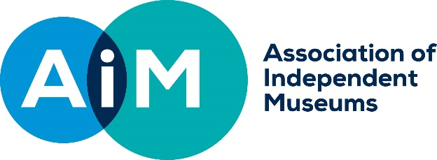

REMEDIAL CONSERVATION GRANT SCHEME 2019
GUIDANCE NOTES FOR APPLICANTS

AIM is grateful to the Pilgrim Trust for funding the Conservation Grant Scheme. The AIM/Pilgrim Trust Conservation Grant Scheme is intended to help small museums with the conservation of objects in their collections. Accessioned objects in any media are eligible. Whilst we expect museums to have a conservation plan, the object does not have to be the most at risk in the collection. However, the reason for your choice must be made clear in your application; for example, the object might be planned for use in a temporary exhibition. Conservation work should be carried out by a conservator chosen from the ICON register (www.conservationregister.com), unless there are exceptional circumstances where this is not possible.

CONSERVATION
For the purposes of the scheme, conservation is defined as: actions to preserve or restore an object.
Preservation: to maintain an object in its present state retarding deterioration
Restoration: to return an object to an earlier state by removing accretions without introducing any new material.

ELIGIBILITY
To be eligible for an AIM Conservation Grant, museums must:
- Be an AIM member
- Be an accredited museum or have ‘Working Towards’ status, (if you are in the latter category AIM reserves the right to discuss your accreditation application with the relevant authority)
- Be a registered Charity, an associated charity can receive the grant on the museum's behalf, if the museum itself is not a charity
- Have fewer than 50,000 visitors p.a. OR a turnover of less than £300,000 p.a. (Please note in the case of branch museums, the total turnover of the parent organisation must be less than £300,000 p.a.)
- Application to this scheme does not prevent museums applying to the Pilgrim Trust for other, unrelated projects
- Applicants may apply to the scheme more than once for different projects

SIZE OF AWARDS
The maximum grant awarded will be £10,000. It is expected that the average grant awarded will be around £5,000. Grants of less than £1,500 will be paid in full on award; others will be paid 50% on award and 50% on completion and receipt of the conservator’s report. Applicants do not need to offer partnership funding although it will be welcome if they do. Bids may be made to part-fund larger schemes but not if that scheme is already being funded by the Pilgrim Trust

ELIGIBLE COSTS
Project costs may include the conservator’s labour and materials, transport (including specialised packing) and reassembly. The grant will NOT cover any costs for your own labour, nor for any subsequent exhibition. We cannot support applications for accidental damage.
If you are VAT Registered, recoverable VAT should be deducted from any invoices before claiming.

CONDITIONS OF AWARDS
- The object must be the property of the applying museum (if the object is disposed of within 10 years the Pilgrim Trust has the right to reclaim the award)
- The object must be put on public display for an appropriate period, having due regard to its sensitivity
- The award should be acknowledged on the appropriate label with the words “Conserved with the aid of a grant from the AIM Pilgrim Trust Conservation Scheme”
- All museums must supply a copy of the conservation report and relevant photography
- If requested, applicants should provide information to the scheme’s external evaluator and or case studies for AIM print or online publications

APPLICATIONS
Applications close on 31 March and 30 September each year. They should be sent by email to the AIM Grants and Finance Officer justeen@aim-museums.co.uk Contact details can be found on the AIM website www.aim-museums.co.uk.

Projects should, ideally, be discussed with the AIM Grants and Finance Officer prior to application. Please contact the office by phone, 0333 305 8060 or by email justeen@aim-museums.co.uk.

MANDATORY ENCLOSURES (electronic pdf versions.)
- Conservator’s Quotation and Treatment Proposal: we expect a conservator to have assessed the subject of the application and provided a quotation and details of how it will be treated?
- Conservator’s CV
- Photos of the object’s present condition: please ensure all photos make clear the scale and particular areas of conservation concern.
- Organisation diagram: please indicate which posts, if any, are paid and the position of the project supervisor.
- Most recent annual report and accounts

ASSESSMENT CRITERIA
- The importance of the object(s) to the museum and its place in the Conservation Plan
- That the object(s) will be on display for an appropriate time (dependent on object type)
- That the project described is appropriate to achieve the aim of preserving or restoring the object
- That the conservator is appropriate
- That post restoration storage and care is appropriate

- Urgency of the conservation required and the stability of the object 5

- Most recent annual report and accounts

The AIM Grants & Finance Officer will acknowledge receipt of all applications and will check that the project is eligible and may contact you to discuss any additional data needed.

Applications will be considered by a committee of AIM Councillors and independent experts. In the case of two applications assessed to be of similar strength, priority will be given to museums that have not previously had a grant from the AIM Pilgrim Trust schemes.

Applicants will be informed of the outcome within eight weeks of each closing date.

Successful applicants will receive a payment for 50% of the grant at the start of the project and 50% upon completion of the grant.

Unsuccessful applicants will be given reasons for their failure and an indication as to whether they can resubmit the same bid for any subsequent round.
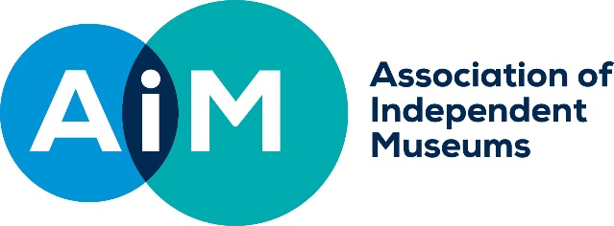

REMEDIAL CONSERVATION GRANT SCHEME 5 – 2019
APPLICATION FORM
Legal name of museum
Name of Museum if different from above
Address
Project leader
Role/Title within museum
Email
Phone
Address if different from above
Grant payee /sort code/ account number | Payee
 | Sort code Account number
Registered Charity number (if you are not a Registered Charity please enclose a copy of your constitution)
AIM membership number
Number of days open to the public in the last calendar year
Annual visitor numbers
Annual Turnover
Accreditation Status/Number
If not Accredited target date for achieving this
Have you discussed the bid with the AIM Grants & Finance Officer? | Yes/No (please cross out accordingly)
Is your organisation registered for VAT (if yes you should exclude the VAT that you can recover from your costings’) | Yes/No (please cross out accordingly)
What is the total project cost?  How much money are you requesting from AIM?  If this is not the total project cost where will the balance come from? Indicate if these sums are secured or when they will be in place? | Total Cost of Project £
 | Grant Sum Request £
Is/Are the object(s) to be conserved owned by the Museum/Trust | Yes/No (please cross out accordingly)
What is the proposed start and end date for the work? | Start date (MM/YY):  End date (MM/YY):
The Chairman of Trustees or Company Secretary should sign below.

I confirm that to the best of my knowledge all the information in this application is true. I declare that I am authorised to make this application and I accept the terms and conditions listed in the guidelines.

Signed
Full Name
Title
Date

GRANT PROPOSAL

ABOUT YOUR PROJECT

- Project Title.
- Description of the project: Please give a brief description of your project – up to 300 words. This should include the reason you wish to carry out the conservation, how it relates to your overall collection. Please describe the object’s current condition and explain why it was chosen for conservation.

- Urgency of the conservation required and the stability of the object.
Is the object unstable or deteriorating rapidly? Is it required for the exhibition? Let us know the deadlines.

- Description of Museum: In up to 50 words please give a brief description of your museum, including what you are a museum of, when you were founded, whether you are volunteer, or staff run etc.
- Heritage importance and significance of the object: In no more than 300 words Please describe the heritage importance and significance of the object/s and its/their place within the conservation plan. If you have any evidence of its heritage merits from outside your organisation, please provide it.

- That the object(s) will be on display for an appropriate time (dependent on object type). Please describe how the object will be displayed, exhibited or stored, post conservation, give details of how the object will be accessed/viewed by the public over the next five years. You will need to provide details on the post conservation conditions and how you will achieve them. If the object is not going to be on permanent display indicate the length of the time it will be on display or its rotation period. Please give the environmental conditions in terms of temperature, relative humidity, light, and security of the area where the object will be exhibited/stored in the future.
- That the project is appropriate to achieve the aim of preserving or restoring the object
Details of the planned conservation work with quote for cost: please include/attach the proposed treatment plan and quotation.
- That the conservator is appropriate
Please give details of the Icon registered conservator and CV of the proposed conservator: if your quote is not from a conservator on the ICON register you will need to give reasons for this, as well as details of the skills and experience of the proposed conservator.
- Has the object(s) ever had conservation treatment before?
- Size of collection / nature of collection /any problems you are aware of (200 words)

