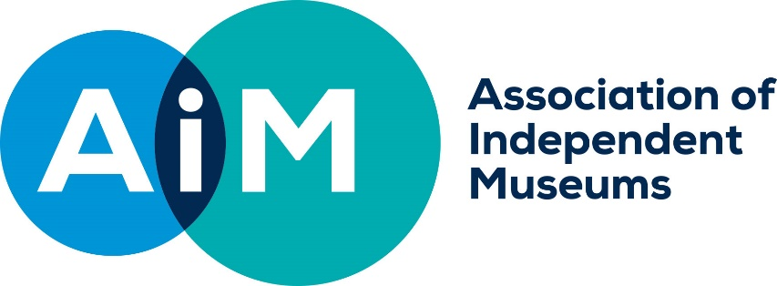

AIM Hallmarks in Wales Grants
APPLICATION FORM: SMALL GRANTS

Legal name of museum (beneficiary of grant)
Legal name of applicant organisation (if not the beneficiary of grant)
Project leader
Role/Title within museum
Email
Phone
Address if different from above
Bank Account Name
Bank Account Sort Code
Bank Account No. (Preferred payment method is by BACS)
VAT Registration No. (if your organisation is VAT Registered, you should exclude VAT when outlining your project costings)
AIM membership number
Accreditation Status/Number
Working Towards Accreditation | Expected Date for achieving Accreditation
Number of days open to the public in the last calendar year
Annual visitor numbers last year

ABOUT YOUR PROJECT

What is the title of your project?
Please give a brief headline description of your project and its aim (up to 25 words).
Use this box to sell your project to the awards committee.

What is the total cost of your project?
How much funding are you applying for?
Where will the balance come from, if applicable?
Expected Start and Completion Dates
Key assessment information
The grants committee will score your proposal against each of the criteria according to the answers you give here. They will also include a score for the overall quality of your proposal and how well you demonstrate your ability to plan and deliver a successful project.

  - Need: explain why the work proposed is needed and demonstrate how it links to the museum’s forward plan.
Type your answer here

  - Impact: what impact will the proposed work have on the organisation’s sustainability? Explain what difference it will make, in terms of income generated or costs saved. Include specific projections for an appropriate period.
Type your answer here

  - Value for money: provide a breakdown of the budget for your project and tell us about any work you have done to research the costs involved.
Type your answer here

  - Innovation: tell us about any characteristics which make your project innovative either for your organisation or for organisations like yours.

Type your answer here

Please specify up to four outcomes for your project that you will report against in your evaluation report. |  | 1.
 |  | 2.
 |  | 3.
 |  | 4.
The Chair or Vice Chair of Trustees should sign below. If submitting electronically, a typed name is sufficient, we will require a hard copy signature on the acceptance form for successful applicants.

I confirm that to the best of my knowledge all the information in this application is true. I declare that I am authorised to make this application and I accept the terms and conditions listed in the guidelines.
Signed
Full Name
Job Title or Role
Date

Mandatory enclosures:

Your application needs to include:
- a completed application form
- the project budget
- current museum budget
- most recent annual accounts and report
- a minimum of one hi resolution image
- a link to your museum website or other marketing materials

Applications should be sent digitally to Justeen Stone, AIM Grants and Finance Officer,
justeen@aim-museums.co.uk t: 01584 878151

