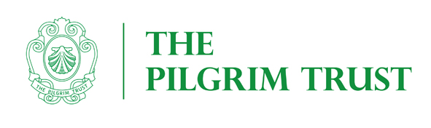
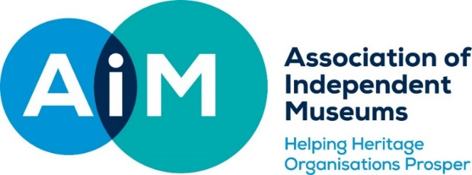

AIM COLLECTION CARE AUDIT SCHEME
AIM is grateful to the Pilgrim Trust for funding the AIM Collections Care Audit Scheme which is being run in association with Icon. It is linked to the AIM Collections Care Grant Scheme. The purpose of this scheme is to enable small museums to have a basic, professional collections care audit, to identify key issues and priorities for their museum, overcoming the financial and other barriers to accessing professional advice. This scheme is open to all UK AIM Members.

The Audits will
• Support the museum to care for its collection more effectively and efficiently in the long-term.
• Support the museum to meet the standards required for Accreditation.
• Ensure that AIM Pilgrim Trust Collections Care grants are effectively used to fund the most important and urgent needs of applicant museums by giving museums the option to undertake an audit before making a full application to the AIM Collections Care Grant Scheme.

ELIGIBILITY
To be eligible for an AIM Collections Care Audit your museum should:
- Be an AIM member
- Be an Accredited Museums or have been awarded ‘Working Towards’ status (if you are in the latter category AIM reserves the right to discuss your accreditation application with relevant body)
- Be a registered charity, an associated charity can receive the grant on the museum's behalf, if the
museum itself is not a charity
- Have fewer than 20,000 visitors p.a.
- Application to this scheme does not prevent museums applying to the Pilgrim Trust for other, unrelated projects

SIZE OF AUDIT
The funded support will be £1,050 (£350 per day) plus travel and VAT if necessary, to cover the costs of the accredited conservator undertaking the audit. Grants will be paid in full to the museum on agreement of the Audit and receipt of the conservator’s report. The grant pays for three days work, not all of which will be onsite at the museum.

AUDIT PROCESS
Museums will use the granted sum to appoint an Icon accredited conservator from the Icon shortlist, to undertake the audit. As part of this audit the conservator will produce a report making recommendations on future collections care and identifying elements where an application to AIM Collections Care Grant Scheme might be helpful. The audit is unlikely to include condition surveys on specific items but will look at the overall condition of the collections and make recommendations for more detailed follow up work as necessary. The grant pays for three days of an accredited conservator’s time;

Day 1: Review of documentation and interviews with staff;
Day 2: To visit the museum to undertake an audit;
Day 3: to produce a short-written report, which highlights and prioritises the key actions which the museum should work towards, to improve the care of its collections.

The report would prioritise the actions both in relation to how urgent they are, how effective they are in moving the collections towards a stable condition or towards being able to be accessed and used, and how easy they are to achieve.

GRANT PROCESS
- The grant notification will be issued after the AIM grants panel meeting to the successful AIM Member.
- The shortlist of the conservators who undertake the audits, (all be Accredited Conservator-Restorer (ACR) members of Icon) will be made available to the museums who have been successful.
- The AIM Member will choose the conservator they wish to undertake the work and will directly engage with the conservator; initially with a discussion by telephone to agree the scope of works, discuss any requirements or timings for the interviews and the museum visit.
- To then agree the final brief, cost of travel, accommodation and VAT (if applicable) and to provide any documentation or previous reports to the chosen conservator for review.
- AIM Member to notify AIM of additional costs of travel, accommodation and VAT (if required)
- After the conservator visit the report will be provided to the museum with the appropriate findings and recommendations.
- Grants will be paid in full to the museum on receipt of the conservator’s report.

CONDITIONS OF GRANT
- If requested, the museum must supply a brief report (max 400 words) suitable for publication in the AIM Bulletin or online, with any relevant photographs within 1 month of completion of the project.
- The museum must supply a copy of the conservator’s report
- If requested, applicants should provide information to the scheme’s external evaluator.

APPLICATIONS
Applications close on 31 March and 30 September 2019.
Applications should be emailed to the AIM Grants & Finance Officer justeen@aim-museums.co.uk
Please remember to email images of the stores and exhibition areas to be audited

Projects should, ideally, be discussed with the AIM Grants and Finance Officer prior to application. Please contact the office by phone, 0333 305 8060 or by email justeen@aim-museums.co.uk.

The AIM Grants & Finance Officer will acknowledge receipt of all applications and will check that the project is eligible and may contact you to discuss any additional data needed.

Applications will be considered by a committee of AIM Councillors and independent experts. In the case of two applications assessed to be of similar strength, priority will be given to museums that have not previously had a grant from the AIM Pilgrim Trust schemes.

Applicants will be informed of the outcome within eight weeks of each closing date.

Unsuccessful applicants will be given reasons for their failure and an indication as to whether they can resubmit the same bid for any subsequent round.

APPLICATION FORM

Legal name of museum (beneficiary of Grant)
Legal name of applicant organisation (if not the beneficiary of grant)
Address
Project leader
Role/Title within museum
Email
Phone
Grant payee /sort code/ account number | Payee  Sort code Account number
Registered Charity number (if you are not a Registered Charity please enclose a copy of your constitution)
AIM membership number
Number of days open to the public in the last calendar year
Annual visitor numbers last year
Accreditation Status /Number
If not Accredited target date for achieving this
Please include images of the stores and collection exhibition areas to be audited

The Chairman of Trustees or Company Secretary should sign below.

I confirm that to the best of my knowledge all the information in this application is true. I declare that I am authorised to make this application and I accept the terms and conditions listed in the guidelines.

Signed
Full Name
Title
Date
- Description of the need: In 300 words include the reasons you wish to carry out the audit, how it fits into your conservation plan (if you have one), supported by your assessment of the risk to your collections
- Description of Museum: In 100 words please give a brief description of your museum, including what you are a museum of, when you were founded, whether you are volunteer, or staff run etc.
- The percentage of the collection impacted by the proposed audit
- Has there ever been a Collections Audit carried out previously, if so when? - What recommendations were made, were they carried out- if not, why not acted upon? (300 words) You may include a copy of the previous audit report.
- Size of collection / nature of collection i.e. types of material/s /any problems aware of (300 words)
- Preferred Conservator (chosen from the AIM Collections Care Audit Shortlist)

Please include images of the stores and collection exhibition areas to be audited.

