Prospering Boards
Application, Stage Two

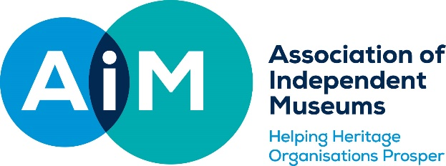

This form should be completed jointly by the consultant who has carried out the diagnostic visit and a representative of the museum board. If the application form is not submitted by the Chair or their representative, the Chair must email Helen Wilkinson, AIM Assistant Director (helenw@aim-museums.co.uk) to confirm that they support the content of the application so that we can be sure that the board is willing to engage fully with the programme of work.

Name of Museum

Name of Consultant

Museum representative completing this form on behalf of the board

Consultant’s report
The consultant should briefly set out the understanding of the museum’s key development needs that she/he has gained from the diagnostic visit. If the consultant thinks any pre-conditions need to be met before support starts, they should outline them here.

Proposed programme of work for Stage 2.
Please explain
- what the outcomes of the proposed support will be
- what process you plan to use
- what the timetable will be and the number of days required
- how the process will be managed for the museum, especially with regard to logistics and diaries

Any additional notes (optional)
Please use this section to explain any significant changes to the proposed programme from the Stage One application, or to give any other necessary context.

Please submit your application to Helen Wilkinson, helenw@aim-museums.co.uk

