Prospering Boards
Application, Stage One

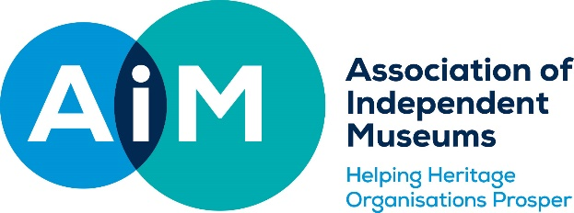

Before completing this application form, please ensure you have read the Guidance Notes. Museums considering an application are strongly encouraged to contact Helen Wilkinson for a preliminary discussion: helenw@aim-museums.co.uk.
- Tell us about your museum.

Name of museum

Approximate annual visitor numbers

Number of paid staff

Number of volunteers

Number of board members

Name and position of the person completing this application
Email address
(for correspondence about this application)

Telephone number
(so we can discuss this application with you)

AIM membership number

Accreditation status

- Describe the challenge or opportunity for the board which you hope to address through this programme. How do you know this is the what your museum needs?

Please refer to the guidance notes for help with this section.

- Proposed programme of work: how much support you need, over what time frame, and how you will use it.

Please refer to the guidance notes for help with this section.

- How will you give the consultant a full picture of the museum’s work at the diagnostic stage?

Please refer to the guidance notes for help with this section.

- What would success look like for your Board as a result of this programme?
In a single sentence, please tell us what difference you think participating in this programme would make.

Please refer to the guidance notes for help with this section.

- Supporting information
We require evidence that this application is supported by the Chair of Trustees and the most senior member of staff (unless this is a voluntary-run organisation). It is extremely important that the Board should have prior knowledge of this application. If the application is not being submitted by the Chair and/or Chief Executive, please ask them to email Helen Wilkinson, AIM Assistant Director, to confirm that the application has their support.

Please indicate here if any information is being sent separately

Your application should be sent, along with a copy of your most recent Annual Report and Accounts to:
Helen Wilkinson, Assistant Director, helenw@aim-museums.co.uk

