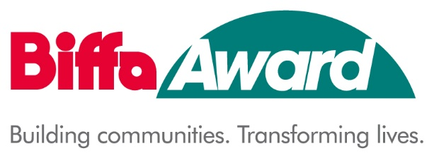
HISTORY MAKERS SCHEME
FULL APPLICATION SUPPLEMENTARY INFORMATION SHEET - PROJECT BUDGET

A | B | C | D | E
Item-  Please provide a detailed breakdown of all expenditure for the project | Total cost of  item | Amount  requested from  AIM Biffa Award | Amount requested  from other  funders/own  reserves | Which funders/own reserves are  providing this?
Eg purchase and installation of projection equipment | £1,500 | £1,000 | £500 | Own reserves
Biffa Award Plaque | £30
Total | £
Other Funders: have you applied to any other funding bodies for funding towards this project? If YES please give details
Name of Funder | Amount requested |  | Result, if known, or date when result expected
Total of other funding

Notes for completion

- Please submit this form at the same time as your Full Application Form.
- Please insert additional rows if necessary.
- AIM Biffa Award would prefer to fully fund an item where possible.
- The total of Column B should be the same as your answer to the ‘Total cost of project’ question in the application form (2.8).
- The total of Column C should be the same as your answer to the ‘Net amount requested from AIM Biffa Award’ in the application form (2.9).
- Please include all other funds you are using for the project in column D. This can include your own funds and any other grants or donations.
- Please include the cost for the Biffa Award Plaque within your budget
- If you can claim your VAT back, please do not include VAT in the costs. If you cannot claim VAT back then do include VAT in the costs.
- Eligible Project Costs. At least 90% of the grant must be used in the creation of new permanent exhibitions/interpretation at your project site. This can include design and development work.
- A maximum of 10% of the grant can be used for supporting work such as, site based education resources or publicity material and creating content for the History Makers virtual trail. Up to 5% project management costs can be included within the 10% management costs. Refer to Section 7 of the application guidance notes or contact AIM if you have a query regarding eligible works
- The 3.27% ENTRUST fee and Third-Party Contribution should not to be entered onto this budget sheet. They are added at Q2.10 and Q2.11 of the application form

