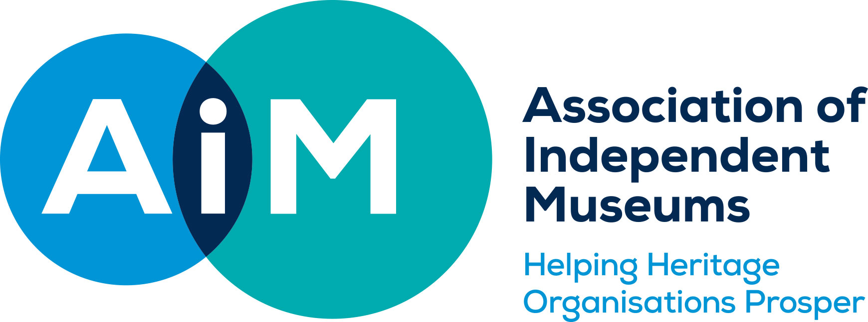
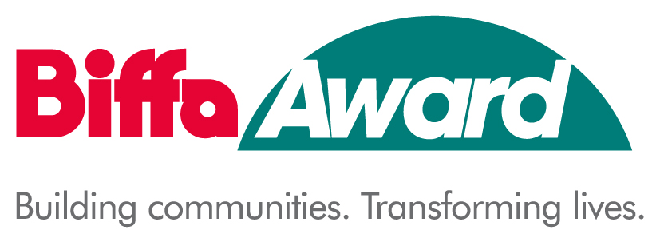
HISTORY MAKERS – People Who Shaped Our World

Expression of Interest (EoI)

The submission of an EoI is the first step in applying for History Makers funding. You should submit the EoI as early as possible. It is your chance to advocate for your History Maker and will ensure your time is not spent on an application that cannot proceed. You can submit the EoI form even if you only have an outline idea of how your project will develop but know who your History Maker is.

The EoI is submitted by email to Justeen Stone justeen@aim-museums.co.uk

The AIM History Makers team will contact you soon to advise you whether or not your project is eligible for a full application. Follow up work at this stage may include a meeting and/or a request for clarification/further information. If your project idea is eligible they will give you advice about how well it fits with the aims and assessment criteria for History Makers. If your proposal proceeds to application, we will be on hand to work with you to develop your idea. Note: the acceptance of your EoI at this stage is not a guarantee of future funding.

Year Three History Makers Expression of Interest (EoI)

Name of organisation
AIM Membership No.
Who should we contact regarding this EoI?
Name
Role in organisation
e.g. Committee Member, Secretary.
Postal address

Postcode
Daytime tel. number
Email address
We use email where possible. Please ensure this email is checked regularly.
Project Location
Address and postcode
History Maker
Please tell us about your History Maker in no more than 200 words:
Tell us about their international, national or regional importance and the significance and impact of their life or work in shaping our world today. What is their legacy?

Office use only Approved eligible for full application? Yes/No Date

