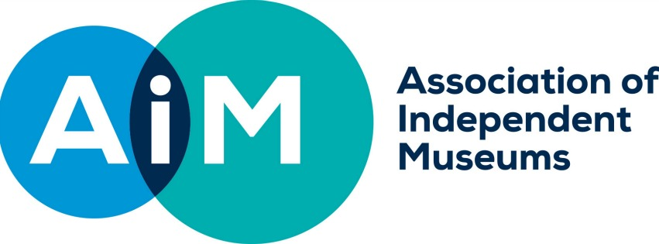

AIM Hallmarks Case Study: Leadership and Culture
Richard Evans, Director, Beamish Museum, County Durham
Good leadership has many elements to it but perhaps, above all, the modern leader needs to know how to adapt his or her style to circumstances, says Richard Evans.
“It’s not about one set of behaviours or attitudes that will do for all time. You need to flex and change according to the scale of an organisation and the position it is in. There are times when it’s about being consensual and democratic and others when you need to take the initiative.”
In 2008 when Richard took the helm at Beamish, he faced a stark situation with an annual £250,000 loss, no reserves and falling visitor numbers. As cuts and job losses loomed, he needed a plan for how to revive its fortunes but, just as importantly, the skills to build a consensus among the staff around the vision.
“Once we had drawn up a four-year plan, I was very open with all staff and volunteers about how much we were bringing in, how much it cost to run things and that what we were going to do was try to improve how Beamish worked,” he says. “Of course, people were upset because there were cuts and it was a very difficult process, but actually people bought into it because they cared about the museum and shared an optimistic vision for its future. People need to see that the motivation of the leader in that situation is neither selfish nor vindictive and that it does involve a plan to improve the organisation to give it a brighter and more stable future.”
Internal PR is important throughout, not just at the beginning, he says. “Once the plan was underway, it was important to be leading from the front in terms of being highly visible in the organisation. So the first time that we opened for the Christmas season, having never done it before, I was there with my sleeves rolled up serving hot chocolate on the first Saturday.”
Eight years on, the turnover has increased from around £5m in 2008-9 to around £11m for 2015-16 with visitor numbers up from 297,000 to 677,000 annually and the museum embarking on a £17m expansion.
Leadership now is about steering the culture and attitudes of the organisation, which means modelling them, not just talking about them.
“Our culture is informal and about recognising and valuing the skills that others have,” he says. “So the way that I, as a leader, work and interact with other members of staff and volunteers is very important. I talk to people as I go around the site, listen to others’ voices and try to have a genuine open door policy.
“Leadership today is very much about authenticity and showing respect for others, rather than asserting yourself. You get far more out of people by giving them space to be excellent than you do by trampling them with your own authority.”
Richard also makes a point of being transparent about the museum’s finances, publishing weekly visitor numbers and how much admissions, catering and retail have made compared with last year, believing that it helps to foster team spirit and engage the staff at a deep level.
A core of trust, shared knowledge and shared values also makes it easier to distribute leadership to other levels of the organisation and encourage others to assume responsibility, which is vital if, like Beamish, the organisation is large, he says.
“It comes from an alignment of personal motivation with the values of the organisation. So it’s about people wanting to work for the museum, wanting to see it develop and succeed in the future and being proud of that.
“It’s quite often the case that when I spot something awry around the museum staff have already seen it and done something about it. There’s that shared purpose at work and it is fundamental.”

