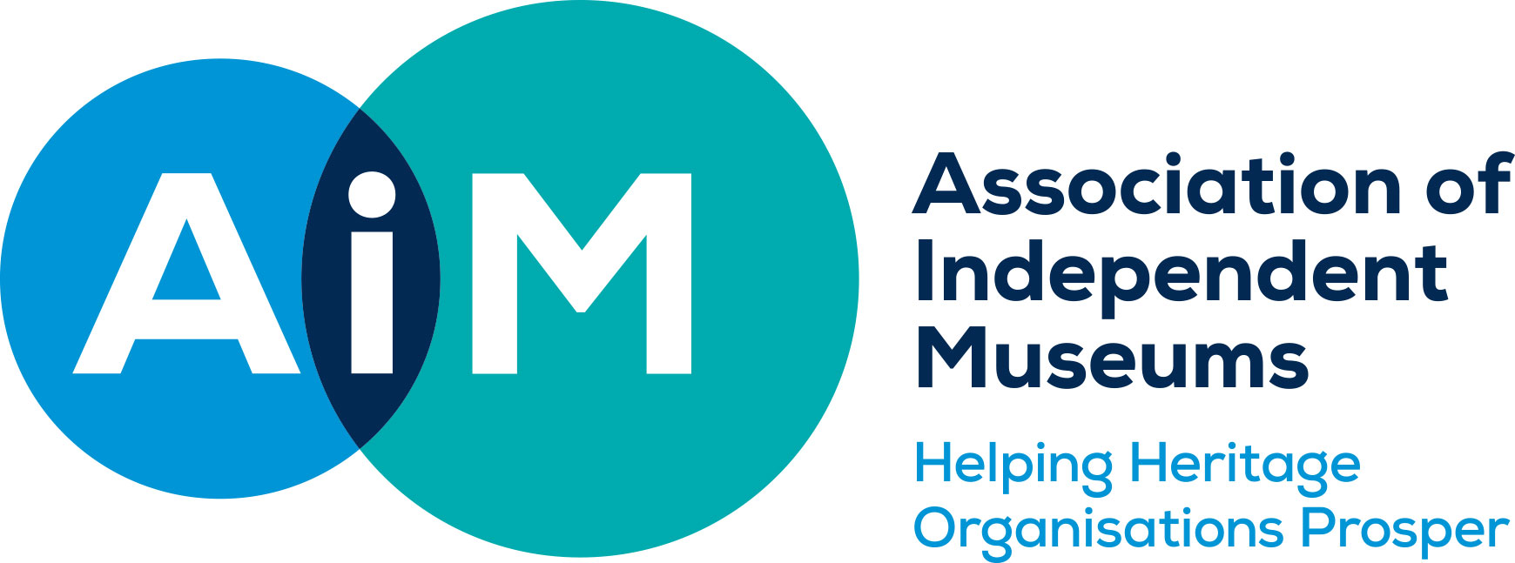

AIM Hallmarks Case Study: Awareness and Networks
Marilyn Scott, Director, The Lightbox

There can’t be many organisations that actively encourage their employees to pop to the shops during working hours for research purposes, but it’s an important part of The Lightbox approach to staying contemporary and relevant.
“We encourage our people to get out and network as much as possible, to attend skills development and training sessions where resources will allow,” says Marilyn Scott.
“We also regularly visit other museums and attractions in small groups to see what other people are doing; we mix our groups up across departments so everyone can take something from a trip.
“With our shop, for example, we encourage them to regularly look at other establishments because retail is such a rapidly-changing area. It’s just as important to know what’s happening on the high street as it is in other museums and heritage sites.
“We’re lucky in that we’re close enough to London to be able to go and do four museum shops in a day to get a feel for product ranges and display which are massive factors when it comes to keeping your own shop up-to-date.”
While the trips out to other museums and galleries are an explicit attempt to keep in tune with the sector and to share knowledge with other professionals, The Lightbox has also forged close and lasting links with its community through a range of local initiatives.
It founded the Woking Arts Hub, a conglomeration of local arts organisations which meets regularly to exchange ideas and discuss programmes and promotions opportunities.
“For example, we worked out an arrangement with the theatre which is just across the road. They have matinee performances every Wednesday so we now host groups of visitors in the morning, show them around and give them lunch before they go to the afternoon show.”
The Lightbox also works closely with local authorities on a variety of events; a recent tie-in was a joint promotion of an HG Wells festival to celebrate the time the author spent in Woking while convalescing from illness. In fact, he wrote War of the Worlds while staying in the town.
“Grass roots activities are very important for us and we understand a lot of the challenges that face local people,” says Marilyn. “We support community groups such as the local homeless charity, the hospice and learning disability organisations to deliver projects and workshops.”
The Lightbox staff are actively encouraged to play a full part in the wider community; while some sit on partnership boards of schools and charities across Surrey, Marilyn herself is a trustee of three other museums and serves of the councils of both AIM and the Heritage Alliance.
“This provides us with the opportunity to bring some really good practice examples to our work at The Lightbox as well as useful knowledge to feed back to our board of trustees,” she adds.
Next, The Lightbox is planning to expand its work with Woking Arts hub as well as its partnerships and other community links, funding permitting. In terms of its work relationships with the sector, one key aim is to embed the principle of networking across the organisation
“We are encouraging middle management staff to also go to networking events and offer to host groups they belong to here,” Marilyn says. “We think it is important not to confine networking to director and senior staff level.”

