AIM Hallmarks Awards

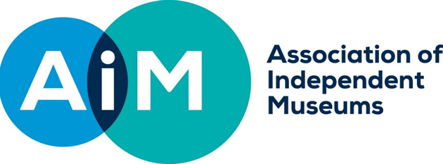

GUIDANCE NOTES FOR APPLICANTS: Round 3

The AIM Hallmarks Awards are designed to support museums to develop their work in relation the AIM Hallmarks of Prospering Museums. The AIM Hallmarks identify what it is about how successful heritage organisations work that enables them to prosper and thrive. To read more about the AIM Hallmarks, see: http://www.aim-museums.co.uk/content/aim_hallmarks/.

Awards will be available in sums of between £5,000 and £15,000, and we anticipate that the average grant will be £10,000. The AIM Hallmarks Awards fund will invest £175,000 in total in museums in England and £45,000 in museums in Wales. The AIM Hallmarks Awards fund is supported by Arts Council England for awards in England and by MALD for awards in Wales.

Decisions on funding in the first round (England only) were made in March 2016 and on the second round, for England and Wales in November 2016. The final round of funding is now open for applications:

*Round three: £22,500 for museums in Wales, £75,000 for museums in England. Closing date: 15th May 2017

These awards will support projects which either:

- Enable museums to consider their organisational health (that is, the areas described in the AIM Hallmarks) and plan or implement future development accordingly
Or
- Take forward an area of work relating to one or more of the AIM Hallmarks, with the aim of strengthening the organisation and enabling it to prosper. Projects can be linked to any of the Hallmarks but must seek to support change at a strategic level and/or to have an impact on organisational culture and behaviour.

Work funded by an AIM Hallmarks Award must be demonstrably central to an applicant museum’s organisational development, and closely linked to the museum’s strategic plan. Museums must be able to show that the work undertaken using the grant could not have taken place without external support.

We are keen to support projects which have the potential to offer helpful lessons to other museums and that are genuinely new for the applicant organisation. This might involve trialling approaches or ways of working which are either wholly new to the museum sector, or new to museums of a particular kind or size.

To be eligible, organisations will have to be:

- In England or Wales
- Members of the Association of Independent Museums (applicants may join at the point of application)
- Either Accredited Museums or formally Working Towards Accreditation.

Assessment Criteria

The grant subcommittee will judge all applications against the following five criteria. Applicants should clearly state and demonstrate how they will meet these in their applications:

Quality of project proposal and link to AIM Hallmarks: how strong is the concept behind the project? How well does the project link to the Hallmarks? Does the project involve change at a strategic level or a change in organisational culture and behaviour? Does the application show that the organisation has good self-awareness of its strengths and challenges?
Opportunity – how well does the organisation demonstrate that this is the right investment at the right time? Is it linked to the organisation’s strategic priorities? Does it represent a new way of working for that organisation? Is it clear that the funding is enabling something to happen which wouldn’t happen otherwise?
Potential for impact – how much difference will this make to the organisation in both the short and longer term? Is the project either sustainable in itself or does it have the potential to put the organisation in a stronger position for the future?
Ability to deliver - How credible is the organisation in its ability to deliver the work funded? How well planned is the project?
Value for money – is the project realistically costed and does it represent good value for money?

Other sources of funding

- These awards can be used to match fund other project funding, providing the award pays for discrete elements of the work that can be separately evaluated, and which would not have gone ahead otherwise.
- (England only) These grants cannot be used to match fund other grants from Arts Council England. However, they could be used to supplement other ACE funded projects and pay for additional elements which would not otherwise be taken forward.

Application Process

The closing dates for applications for the second round is 15th May, 5pm.

Where possible, our preference is for all parts of the application to be sent electronically. Where necessary,
supplementary material may be sent in hard copy to arrive by 22nd May.

Applications should be sent to the AIM Administrator, aimadmin@aim-museums.co.uk

If sending supplementary materials in hard copy, address details can be found in the AIM Bulletin and on the AIM Website www.aim-museums.co.uk

Your application needs to include:
a completed application form
a detailed project description, including action plan, timetable and budget. This document can be up
to 4 A4 pages in length.

When preparing your project description, you need to ensure the links to the assessment criteria are
clear, and that you give the assessment panel enough information to answer all the questions listed.

Please use the following headings:
1. Project proposal and link to AIM Hallmarks (see criterion 1)
2. Opportunity (see criterion 2)
3. Impact on the organisation (see criterion 3)
4. Project plan and timetable (see criterion 4)
5. Budget (see criterion 5)

current museum budget
most recent annual accounts and report
a link to your museum website. If you do not have a website, please send hard copies of your
current publicity flyer or other marketing materials

Applicants will normally hear the result of their applications within 6-8 weeks of the closing date. Successful applicants will receive 80% of their grant immediately with the balance being paid on completion of the project. Successful applicants will be required to participate in our project evaluation and we will confirm what information we require when awards are made. Requirements include a baseline questionnaire, and an end of project return

Advice on any aspect of the grant scheme can be obtained from Helen Wilkinson, AIM Assistant Director, helenw@aim-museums.co.uk, 0771 966 7102. Museums planning to make an application are strongly advised to discuss their proposals with Helen before preparing a detailed application.

FAQs

What costs are eligible for support under the AIM Hallmarks Awards?
If you have any queries about what kinds of projects the Awards will support and what costs are eligible,
please contact Helen Wilkinson for advice. In the first two rounds, the committee made grants to support a wide
range of projects as well as for organisational review. It gave preference to projects which sought to develop
ideas and consider new ways of working, rather than those which involved simply buying new equipment or
materials.

Can a museum that is not Accredited apply for a grant?
Museums must either be Accredited or formally Working Towards Accreditation.

Can two or more museums apply for a grant together?
Joint applications from two or more museums are welcomed, but both or all must be AIM Members, open to the public and either Accredited or formally Working Towards Accreditation.

Are there any restrictions on the size of museums that can apply?
No, all museums that meet our other criteria can apply, although we will look at museums’ capacity to deliver the project (do they have the necessary capacity?) and the difference the award will make to that museum (is their turnover so large that our award will have a relatively minor impact?).

I am a Local Authority Museum, can I still apply for an AIM Investing in Independence Award?
Yes, all AIM members which meet the other eligibility criteria can apply. However, the awards are designed to fund projects closely linked to the AIM Hallmarks and ways of working that characterise ‘independent spirited’ organisations, whatever their governance structure.

Why are the awards only open to museums in England and Wales?
This is a requirement of our funding for this programme, which is from Arts Council England and from MALD.

What percentage of my total project cost will you fund?
There is no set requirement for a contribution from the applicant museum and we will fund up to 100% of project costs in principle. However, we will take value for money into account when assessing applications.

How long do we have to spend the award?
We envisage that awards will usually be spent within 9-12 months of the award and we will look for a realistic timetable in assessing applications. All funding must be spent and the final evaluation completed by March 2018.

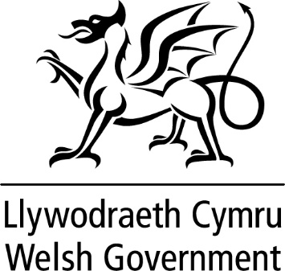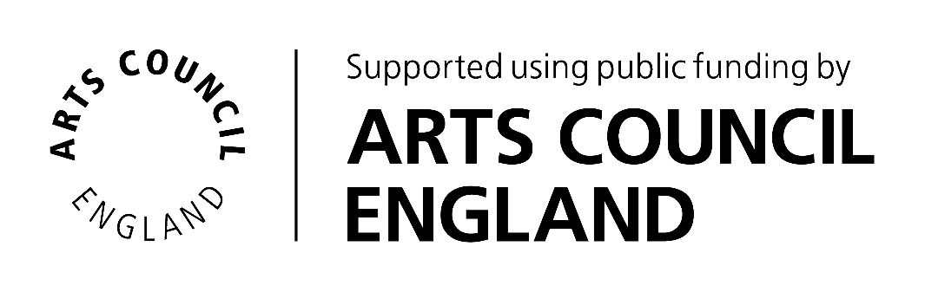

AIM Hallmarks Awards

APPLICATION FORM

Legal name of museum (beneficiary of grant)
Legal name of applicant organisation (if not the beneficiary of grant)
Project leader
Role/Title within museum
Email
Phone
Address if different from above
Bank Account Name
Bank Account Sort Code
Bank Account No.
Preferred payment method is by BACS, should you wish to receive a grant cheque please state to whom the grant cheque should be made payable.
VAT Registration No. (if your organisation is VAT Registered, you should exclude VAT when outlining your project costings)
Registered Charity number (if you are not a Registered Charity please enclose a copy of your constitution)
AIM membership number
Accreditation Status/Number
If not Accredited target date for achieving this
Number of days open to the public in the last calendar year
Annual visitor numbers last year

PROJECT PROPOSAL

ABOUT YOUR PROJECT

What is the title of your project?
Please give a brief description of your project and its aim (up to 25 words).

Use this box to sell your project to the awards committee. You will need to provide a more detailed project description, action plan and project budget – see the note on Mandatory Enclosures at the end of this application form.

What is the total cost of your project?

How much funding are you applying for?
Where will the balance come from, if applicable?

Please Specify up to four outcomes for your project that you will report against in your evaluation report. | 1.
 | 2.
 | 3.
 | 4.
The Chair or Vice Chair of Trustees should sign below. If submitting electronically, a typed name is sufficient and we will require a hard copy signature on the acceptance form for successful applicants.

I confirm that to the best of my knowledge all the information in this application is true. I declare that I am authorised to make this application and I accept the terms and conditions listed in the guidelines. I accept that AIM may share application information with the relevant local Museum Development Team or similar organisation.
Signed
Full Name
Title
Date

Mandatory enclosures:

Your application needs to include:
a completed application form
a detailed project description (see above)
current museum budget
most recent annual accounts and report
a link to your museum website. If you do not have a website, please send hard copies of your
current publicity flyer or other marketing materials

Applications should be sent to the AIM Administrator, aimadmin@aim-museums.co.uk

If sending supplementary materials in hard copy, address details can be found in the AIM Bulletin and on the AIM Website www.aim-museums.co.uk



